The Spring Boot CLI :

The Spring Boot CLI is a command line tool that can be used if you want to quickly prototype with Spring. It allows you to run Groovy scripts, which means that you have a familiar Java-like syntax, without so much boilerplate code.

pre-requisite:

-Maven
-

- set path to env variable ( D:\Users\lnc\Downloads\spring-boot-cli-1.5.4.RELEASE-bin\spring-1.5.4.RELEASE\bin)

- create a HelloWorld in java -> save it as HelloWorld.groovy

> spring run HelloWorld.groovy

#to change the port on the run
> spring run HelloWorld.groovy -- --server.port=8085
Spring Boot CLI
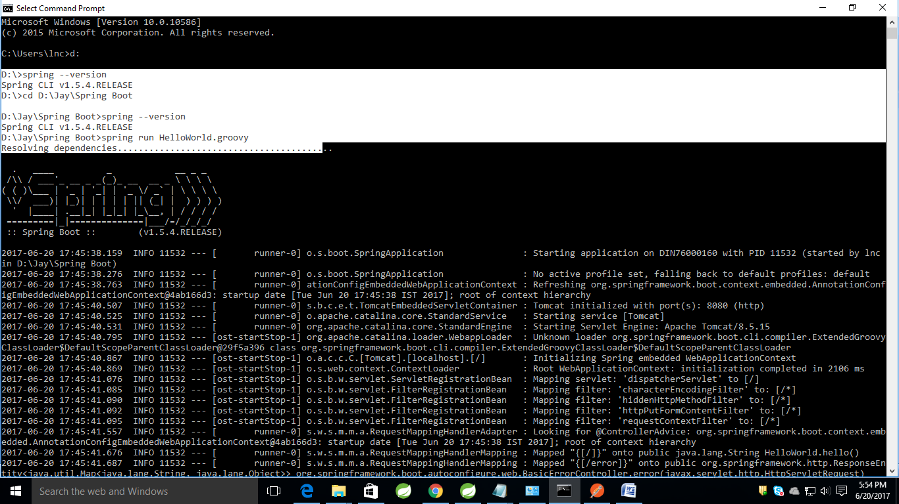

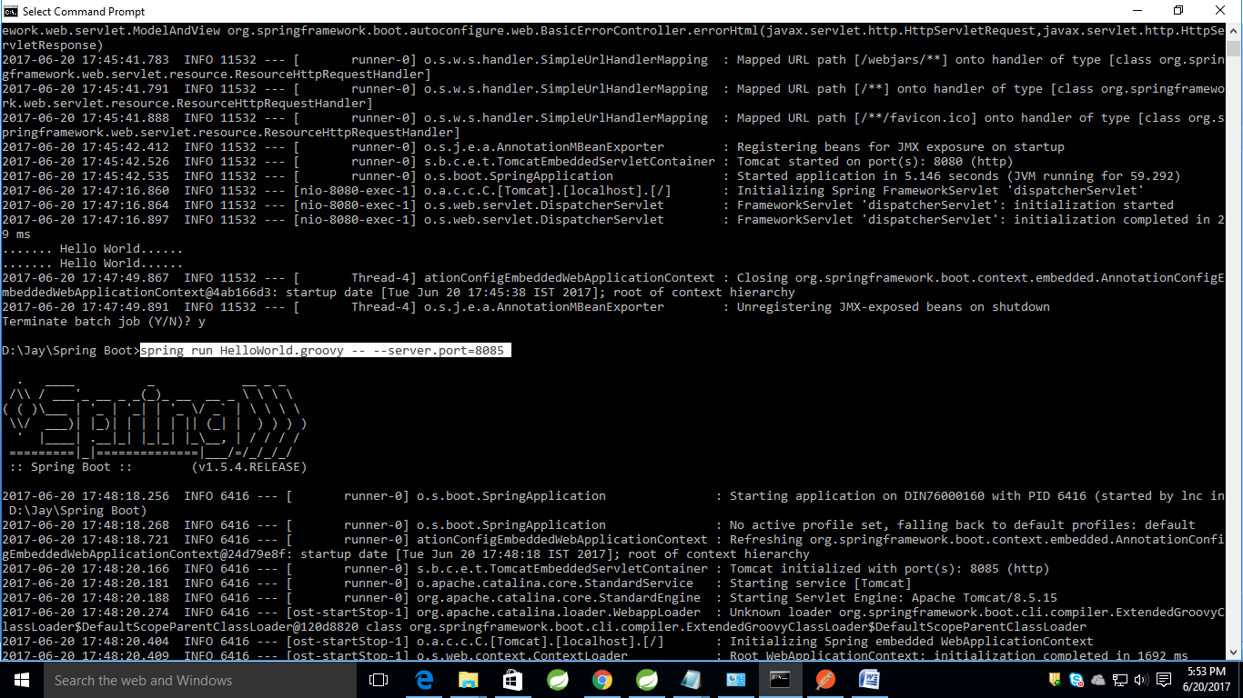

Spring Starter
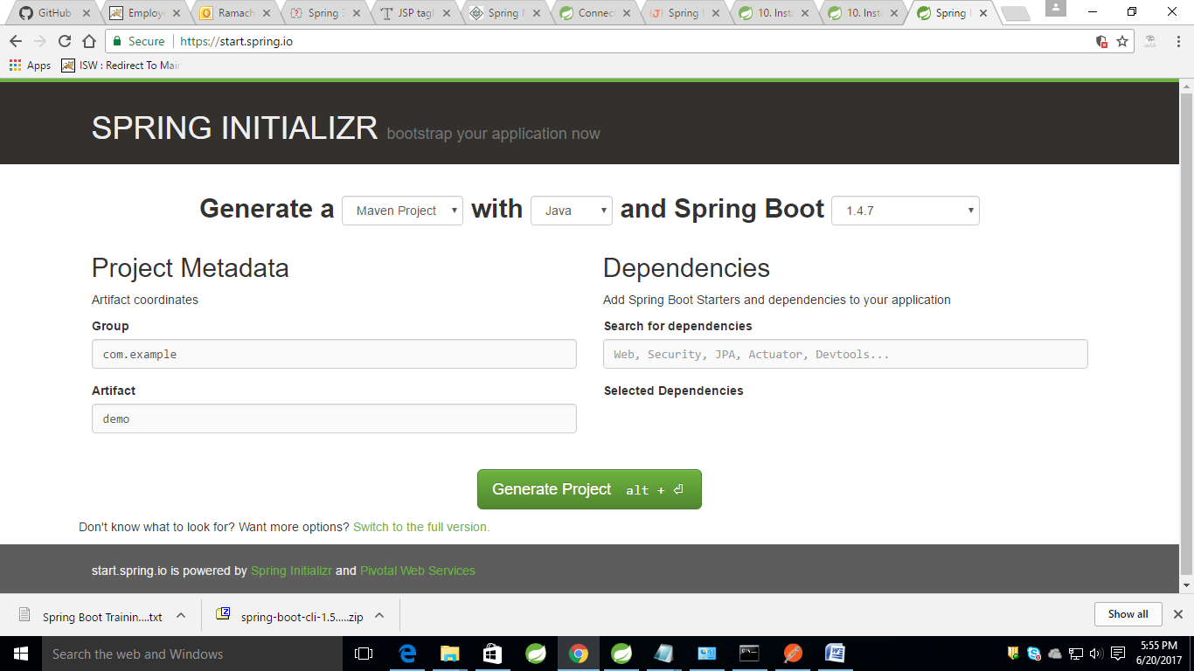

Select needed spring modules and based on options and download the pom.xml and project artifacts using Generate Project button

\
